WiFi Sniffer with UBUNTU on rPI5

rPI HW
I’m using the rPI5 with a 1TB SSD. The rPI is booting from SSD. There is no SD-Card in the rPI 5.
The possibility to boot from external SSD is possible with a from rPI3 on. There are tutorials in the WWW.
I’M using UBUNTU desktop which needs at least 4GB RAM on the rPi

https://www.raspberrypi.com/documentation/computers/raspberry-pi.html#imager

Creating bootable external SSD
Download and install the “Raspberry Pi Imager” on a Windows PC. You can download it here:
https://www.raspberrypi.com/software/

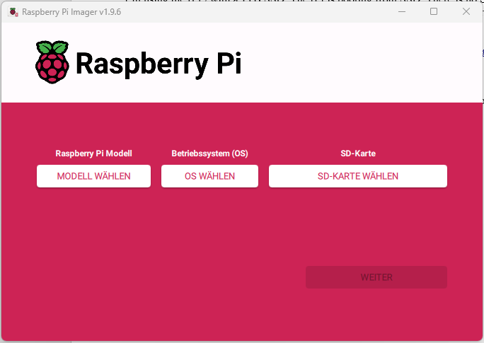

Select the rPI model:


Select the OS:




Select the SSD:

Click on next:

Click on OK:
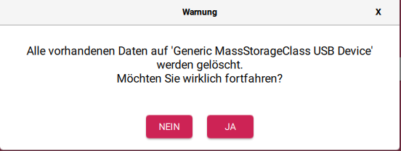
Wait till the OS is written and verified:

Now you can use the SSD in the rPI:
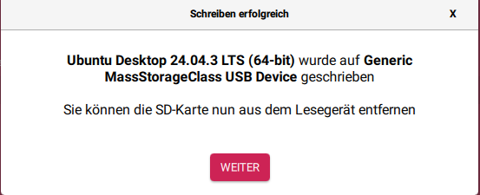

sudo adduser $USER wireshark
sudo chmod +x /usr/bin/dumpcap

sudo iw dev wlan1 scan |egrep -i 'SSID.*ost' -A 2|grep -i channel|head -1|grep -Eo '[0-9]{1,4}

Capture stop conditions:
-c <packet count> stop after n packets (def: infinite)
-a <autostop cond.> ... duration:NUM - stop after NUM seconds
filesize:NUM - stop this file after NUM KB
files:NUM - stop after NUM files
Capture output:
-b <ringbuffer opt.> ... duration:NUM - switch to next file after NUM secs
filesize:NUM - switch to next file after NUM KB
files:NUM - ringbuffer: replace after NUM files

#!/bin/bash
echo "version 1.0"
if [[ $EUID -eq 0 ]]; then
echo "Don't run the script as root or sudo"
exit 1
fi

if [ $# != 2 ]; then
echo "usage:"
echo "sniffer [WLAN device] [WiFi channel]"
exit
fi
while true; do
read -p "Do you wish to configure device $1 to channel $2 in monitor mode ? y/n " yn
case $yn in
[Yy]* ) break;;
[Nn]* ) exit;;
* ) echo "Please answer yes or no.";;
esac
done
while true; do
read -p "Delete files in trace directory? y/n " yn
case $yn in
[Yy]* ) rm ~/tshark_logging_files/*;break;;
[Nn]* ) break;; * ) echo "Please answer yes or no.";;
esac
done

echo ""
echo "$1 is using this channel:"
sudo iwlist wlan1 channel |grep Current

echo "Shutdown $1 ..."
sudo ifconfig $1 down
echo "Set $1 to monitor mode ..."
sudo iwconfig $1 mode monitor
echo "Unblock wlan ..."
sudo rfkill unblock wlan
echo "Startup $1 ..."
sudo ifconfig $1 up
echo "Setting channel $2 on $1 ..."
sudo iwconfig $1 channel $2
echo "$1 is on this channel"
sudo iwlist wlan1 channel |grep Current
echo "Creating directory \"~/tshark_logging_files/\" for traces if it not already exists..."
if [ ! -d ~/tshark_logging_files ];then
mkdir ~/tshark_logging_files
fi
# tshark -i wlan1 -w ~/tshark_logging_files/test.pcapng
tshark -i wlan1 -w ~/tshark_logging_files/$1_channel_$2_.pcapng.gz -b filesize:10000 -b files:10

Make a rPi 3 bootable from USB SSD
Prepare a SD card with the Pi OS:

Boot The rPi 3 from SD card
echo program_usb_boot_mode=1 | sudo tee -a /boot/config.txt
sudo reboot
vcgencmd otp_dump | grep 17:
Result must be:
„17:3020000a“
sudo shutdown -h now

The rPi 3 should be now able to boot over USB.

Configure Ubuntu Server

Configure keyboard
sudo dpkg-reconfigure keyboard-configuration

Configure SSH
sudo apt install openssh-client
sudo apt install openssh-server

